1.**Report View**Navigating to the report view tab wil give a dashboard and a chart that will be selected for data visualization, we can select any type of chart as per our need example sales store data  
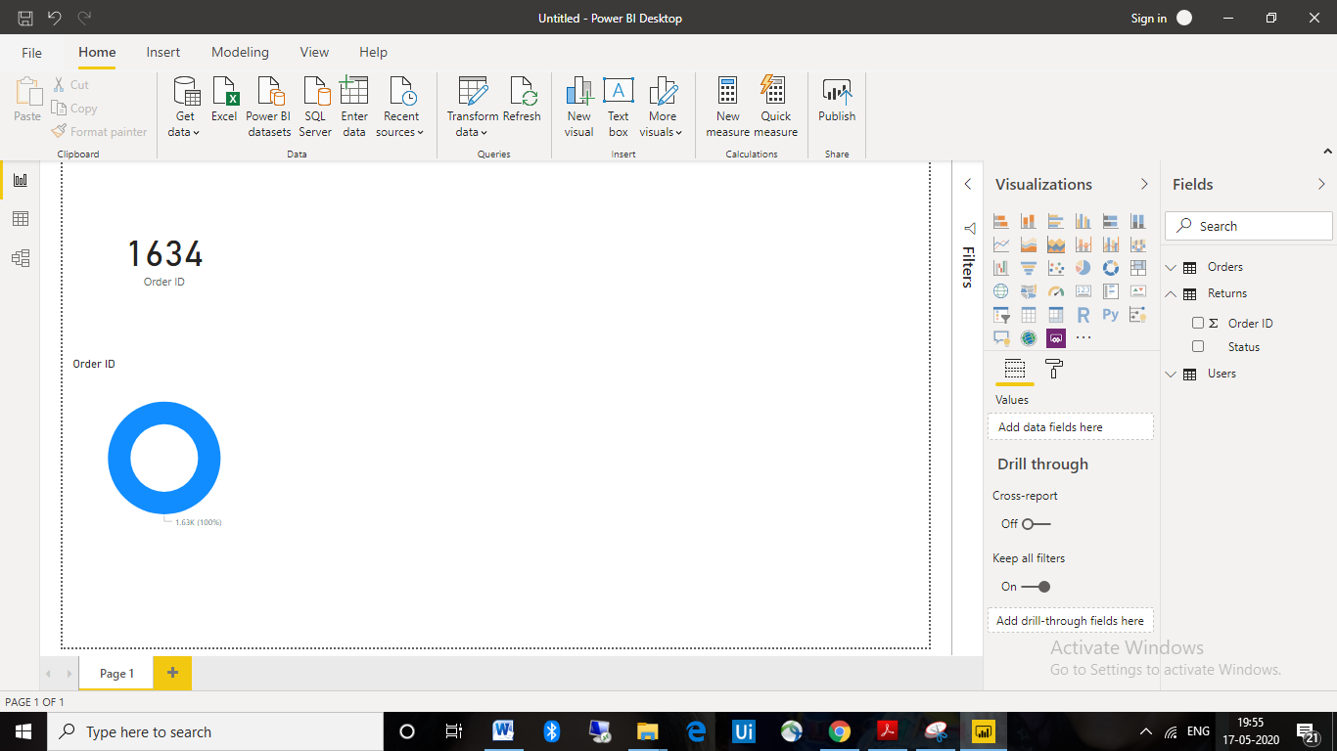  
 **2. Data view   
Navigating to the Data tab view you can view all the data defined as per the replationship from the data sources**  
  
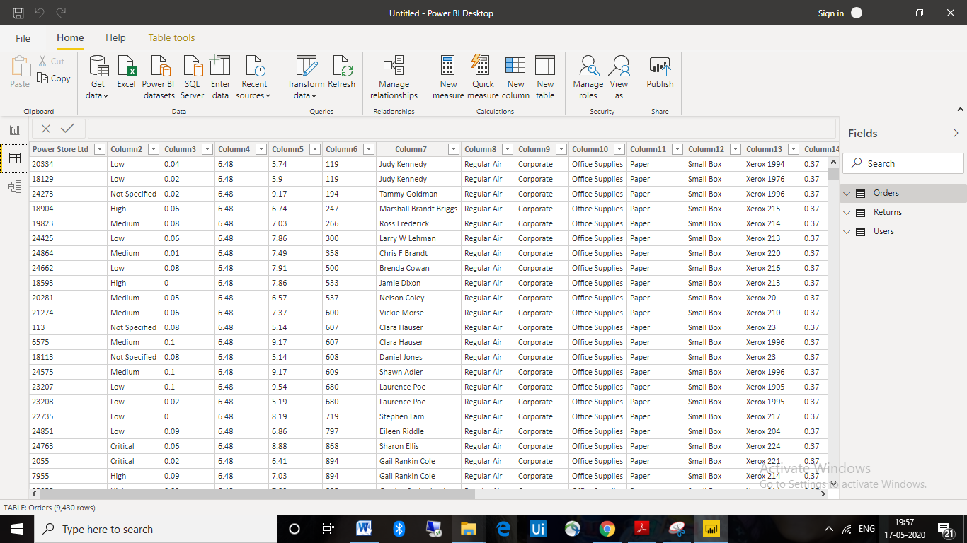  
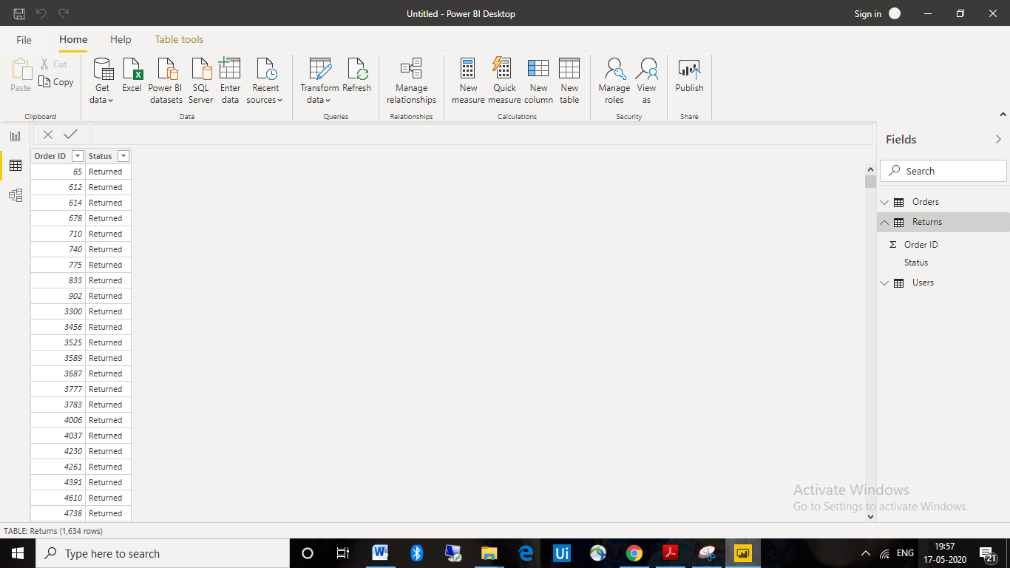

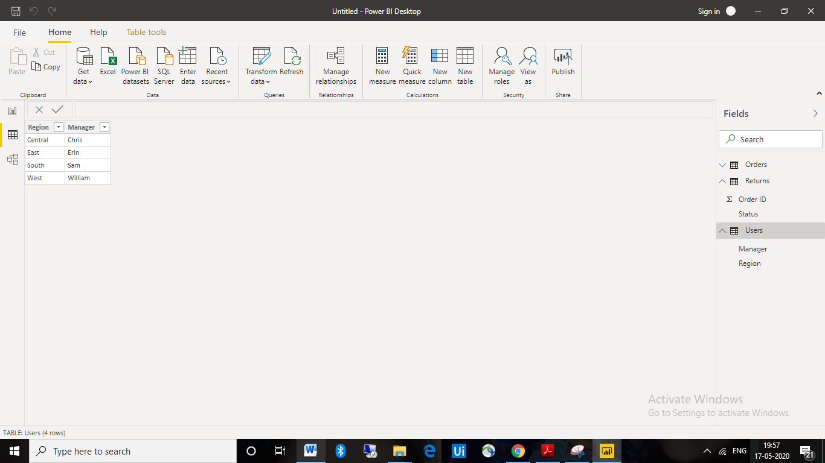

**3.Model view**

**Navigating to the model view you can** add and remove relationships. Right click and select delete this will remove a relationship . just drag and drop the fields which you want to link between different data source and create a new relation ship . we can also hide the relationship.

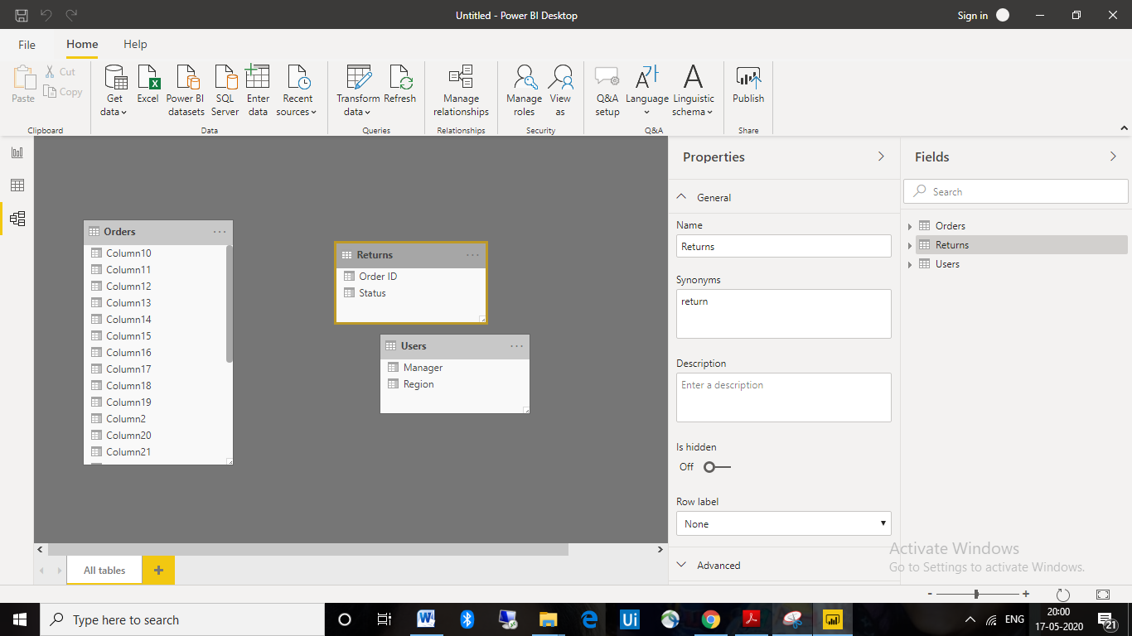

**4.Power query editor**  
 here the data will be transformed as per our need , we’ll filter the data and keep those data which we want.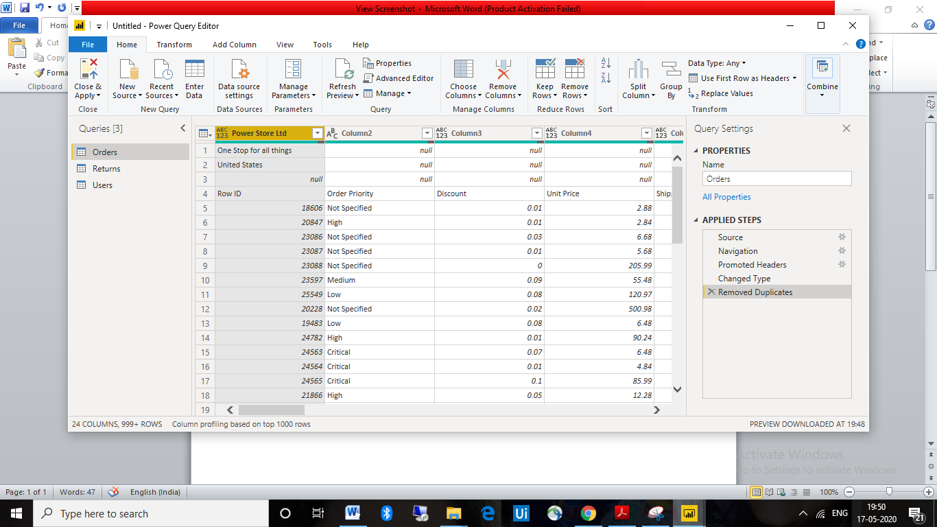

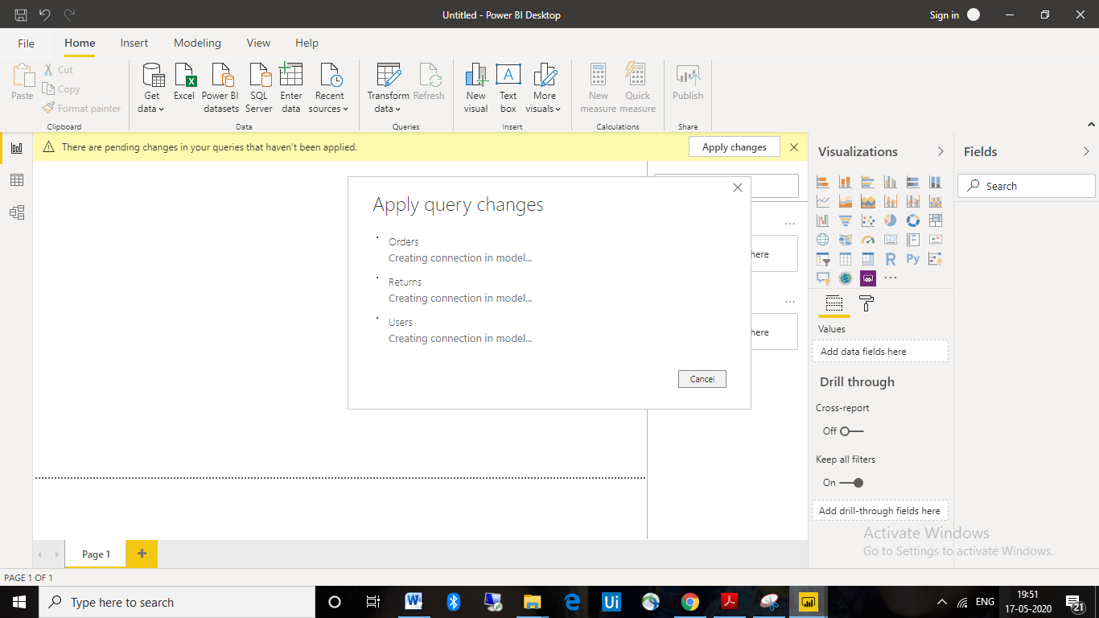

**5.advance editor**

This function works with power query and performs a lot of complex steps with any type of data source   
